**Elsevier QE Test**

**TASK1 Bug Reporting**

Go to <https://www.scopus.com/search/form.uri?display=basic&zone=header&origin=searchbasic> and report few of the bugs that you find. For a template use any bug reporting system that you like. Write them in sections below.

Bug Reporting Tool: **JIRA**

**To Create a new Bug in JIRA**

1. Issues-->Issue Types-->Bug

**Create Issue:**

**Summary:**

On clicking on "Scopus discontinued book list" takes to 404 error Page

**Desription:**

When we click on "[Scopus discontinued sources list](https://www.elsevier.com/?a=212275)" link in the scopus content it takes to 404 page not found error.

**Priority**: P1

**Environment**: Prodution

**Attachment**:

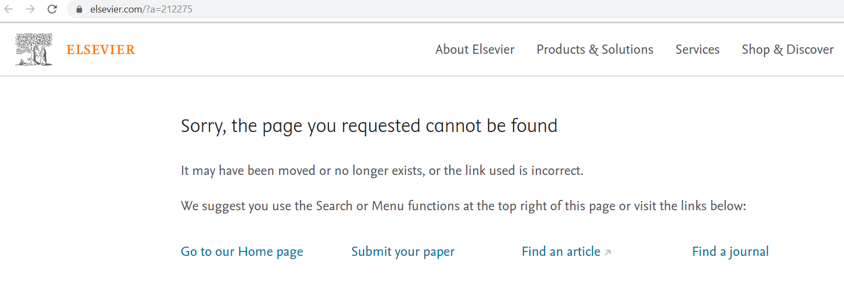

**Assignee**: Developer

2. Issues-->Issue Types-->Bug

**Create Issue:**

**Summary:**

Follow in different media should have a message and should be placed in footer.

**Desription:**

Follow in different media should have a message and should be placed in footer.

Eg: LinkedIn, Twitter,FaceBook and Youtube

should be placed in the footer not in the body and the heading is missing

**Priority**: P3

**Environment**: Prodution

**Attachment**:

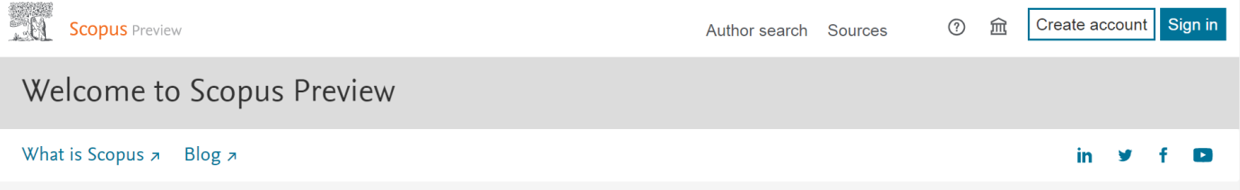

**Assignee**: Developer

**3**. Issues-->Issue Types-->Bug

**Create Issue:**

**Summary:**

Language should be replaced with **Languages**

**Desription:** Language with Singular word should be replaced with Languages.

**Priority**: P3

**Environment**: Prodution

**Attachment**:

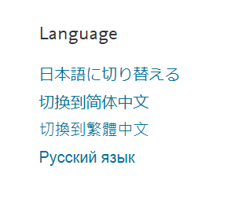

**Assignee**: Developer

**4**. Issues-->Issue Types-->Bug

**Create Issue:**

**Summary:**

While clicking Help and Contact Us pages lands in same page

**Desription:**

In Footer while clicking Help and Contact Us pages lands in same page.

**Priority**: P3

**Environment**: Prodution

**Attachment**:

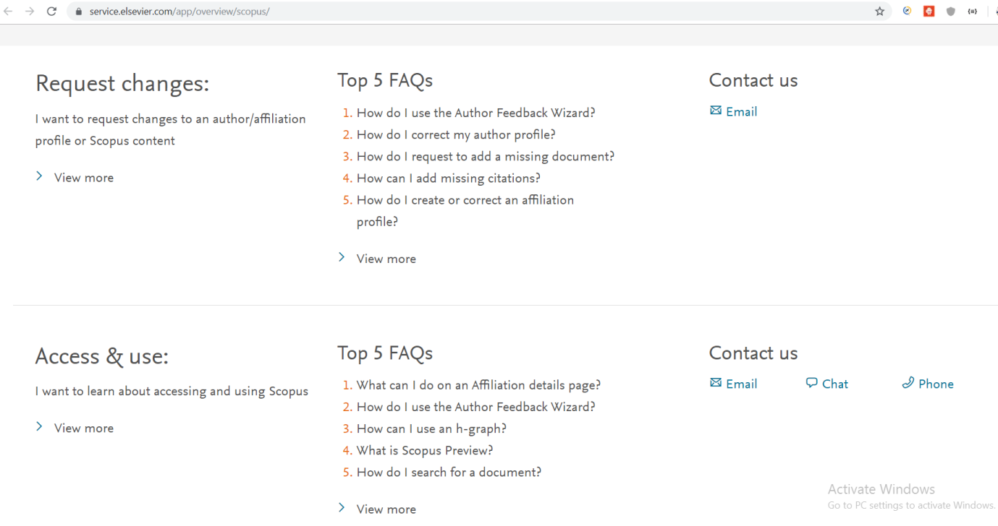

**Assignee**: Developer

**TASK 2 Manual Test Scripts**

Go to <https://www.scopus.com/sources.uri?zone=TopNavBar&origin=searchbasic>and white few manual test scripts for the filtering functionality. Write them in sections below.

<https://www.scopus.com/sources.uri>

1. Check by clicking any search criteria ie, Subject area,title,etc. its relevant blank should be displayed. by entering a keyword in blank, its relevant suggestion should be displayed in dropdown.
2. Verify when no filter is selected, apply button should get greyed out(disabled). When at least one filter is selected, apply button should be enabled.
3. Verify the view metrics for a given year from dropdown and results should display according to the year seleted.
4. Verify the sort ascending and descending order for source title,citescore,etc.
5. Verify under section, Counts for previous 3 years, the blanks should be enabled only when their corresponding radio buttons are clicked.
6. Check if filter results are displayed on selecting each and every criteria
7. Check if we are able to change the display number of results per page
8. Verify by selecting "All" checkbox in the result section, see if all the results are selected
9. Check if we are able to select any 1 result and export to excel sheet by using the option given in the result header section
10. Check by clicking clear filter, all the search criteria's should be cleared
11. Verify by clicking the arrows in filter section, check if we are able to expand and collapse a section

**TASK 3API Test**

You have an API request for authentication. Please add missing parts and write a few main test scenarios:  
Request ->  
Method: **POST**   
Headers:  "**Content-Type","application/json**"  
Endpoint:  **https://someUrl/login**  
{  
“name”: “some name”,  
“pass”: “password”  
}  
Response ->  
**{**

**HTTP/1.1 201 Created**

**Status: "Successfully Created"**

**}**

**TASK 4 Test Automation**

Go to <http://automationpractice.com/index.php> and using Java, write an automated test to verify that summer dresses can be added to the cart and it’s possible to proceed to the Sign in section. Paste your finalized code here or provide us the online repository project path to access.

Elsevier full project to download:



Elsevier project structure:

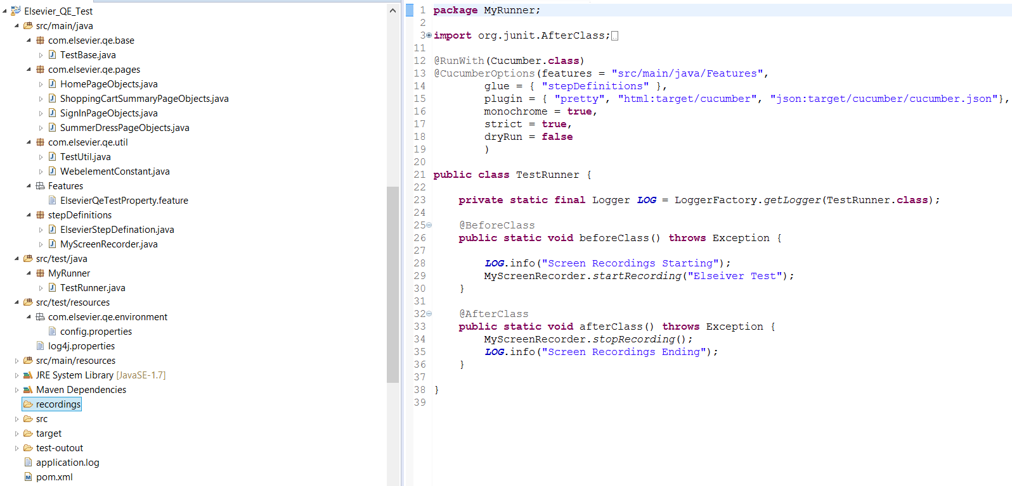

To see the test run:

In the recordings folder select the file and right click and run as VLC media player.

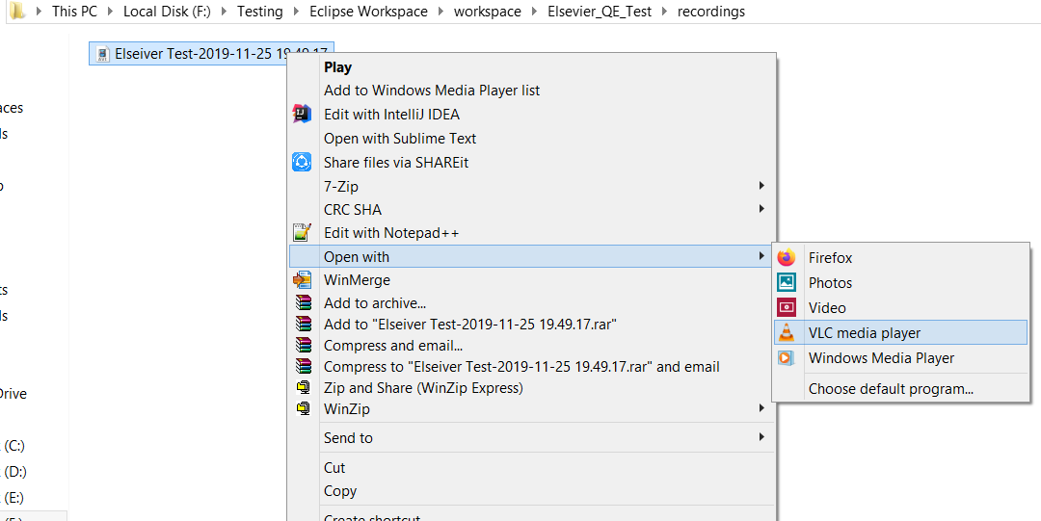



Maven test :

